Digital Signal Processing Project of Chapter 2

Homework 1 – 1

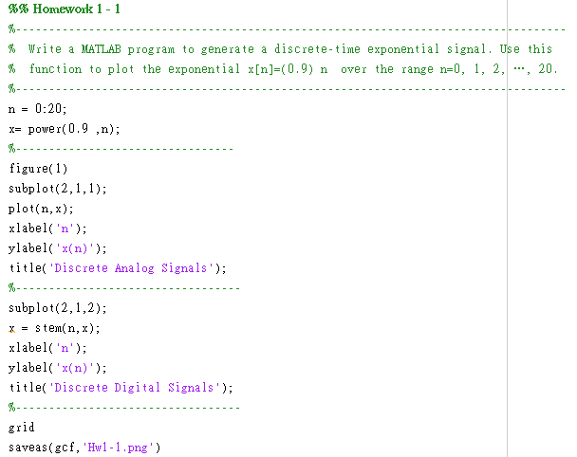

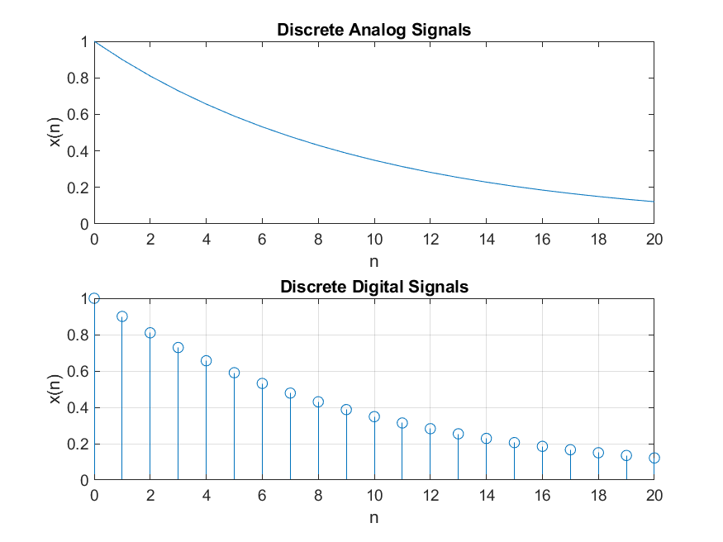

The homework 1-1 have 2 figures , Discrete Analog Signals (right top) and Discrete Digtial Signals(right bottom).

This code said :

1. Use n = 0: 20 arranged the range is 0 to 20.
2. The mathematical function is ${0.9}^{n}$.
3. First use plot() function to plot the mathematical function.
4. Second use stem() founction to stem the mathematical function.
5. Finally , save the total figure.

Home work 1 – 2a

Using recursion $y\left[n\right]=1.8\cos\left(\frac{π}{16}\right)y\left[n-1\right]-0.81y\left[n-2\right]+x\left[n\right]+\frac{1}{2}x[n-1]$ generate and plot the impulse response h[n].

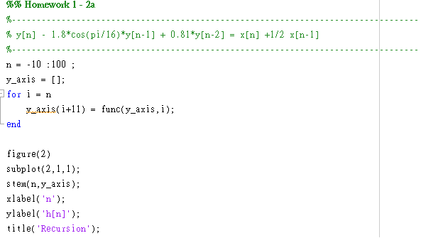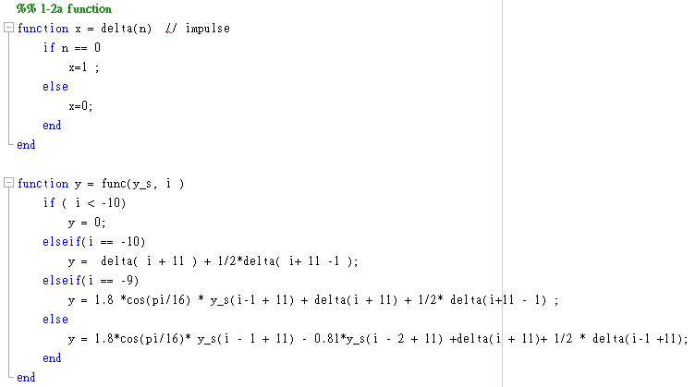

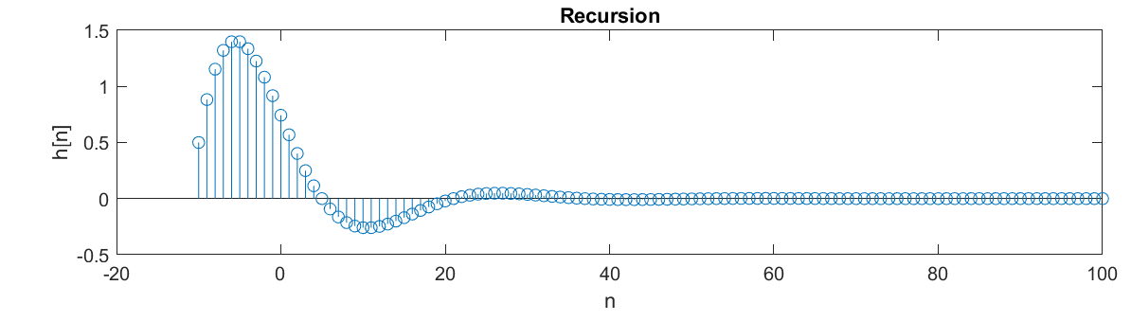

Homework 1-2a use a recursion to generate signals , but the recursion is too slow to run.

So when it run the recursion , it must record it variables itself.

Function 1 $x[n]= δ[n]$

$$\left\{\begin{matrix}x[n]=1, n=0, \\ x\left[n\right]=0,n-1.\end{matrix}\right.$$

Function 2 Recursion

$$\left\{\begin{aligned}\begin{matrix}y\left[n\right]=0 , n<0, \\ y\left[n\right]=δ\left[n\right]+\frac{1}{2}δ\left[n-1\right] , n=0, \\ y\left[n\right]=1.8\cos\left(\frac{π}{16}\right)y\left[n-1\right]+δ\left[n\right]+\frac{1}{2}\left[n-1\right] ,n=1, \end{matrix} \\ y\left[n\right]=1.8\cos\left(\frac{π}{16}\right)y\left[n-1\right]-0.81y\left[n-2\right]+δ\left[n\right]+\frac{1}{2}\left[n-1\right],otherwise.\end{aligned}\right.$$

Homework 1-2b

Using the filter function generate and plot the impulse response h[n].

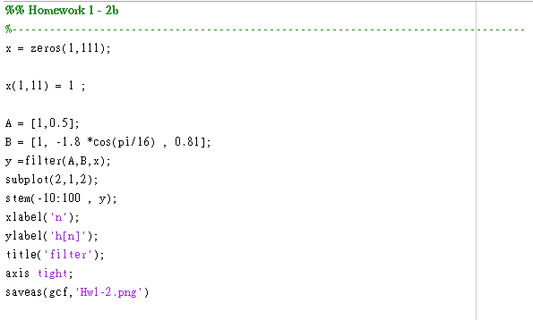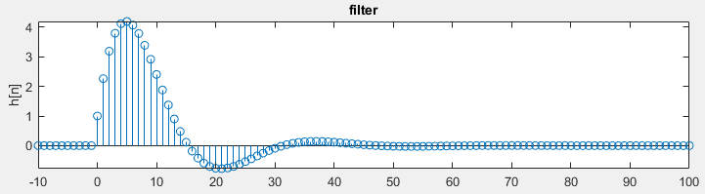

Using filter function is easy and no Time-consuming.

Just dismantle the recursion :

$$\left[1, -1.8\cos\left(\frac{π}{16}\right), 0.81\right]$$

And use filter() to finish the work.